**NAME** :- Manish Shashikant Jadhav

**UID** :- 2023301005.

**BRANCH** :- Comps -B. **BATCH:** B.

**EXPERIMENT 10: Implement Pl/SQL procedures and functions.**

**SUBJECT** :- DBMS (DATABASE MANAGEMENT SYSTEM)

1. **Write the PL/Sql  anonymous block to calculate the area of circle for value of radius varying from 3 to 7. Store the radius and corresponding values of calculated areas in a table called Areas and display the table areas.**

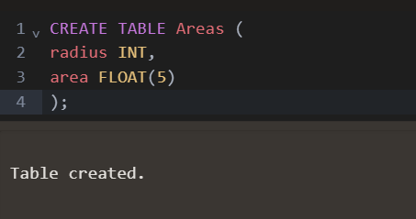

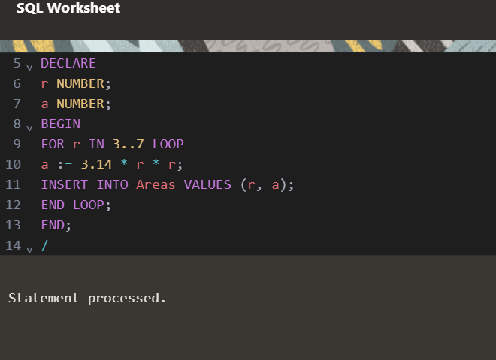

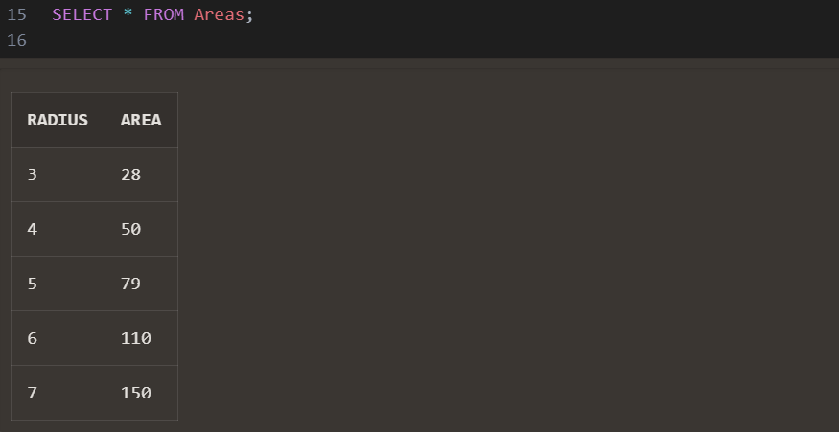

1. **Create a table Book(ID, Title, Author). Write a function to**[**insert**](https://moodle.spit.ac.in/mod/resource/view.php?id=2876)**the values of all attributes in Book table .**

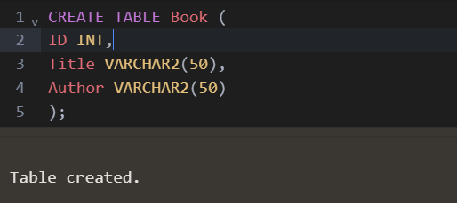

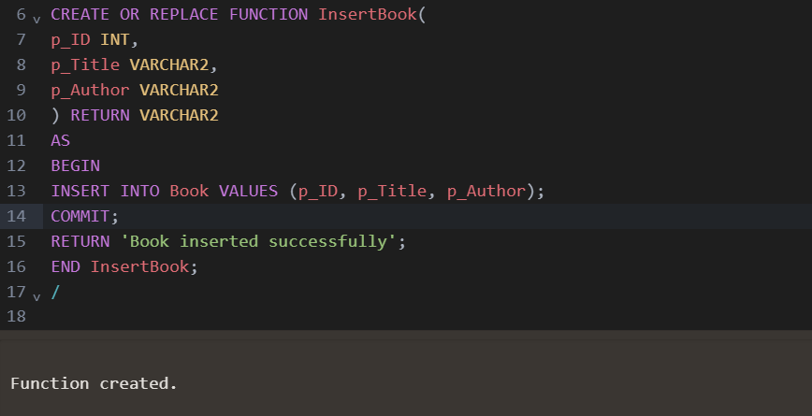

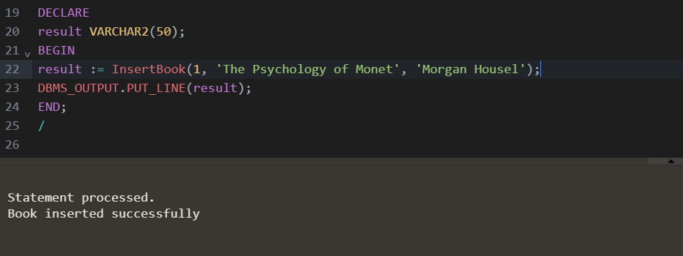

1. **Create a function to update the values of Book table**

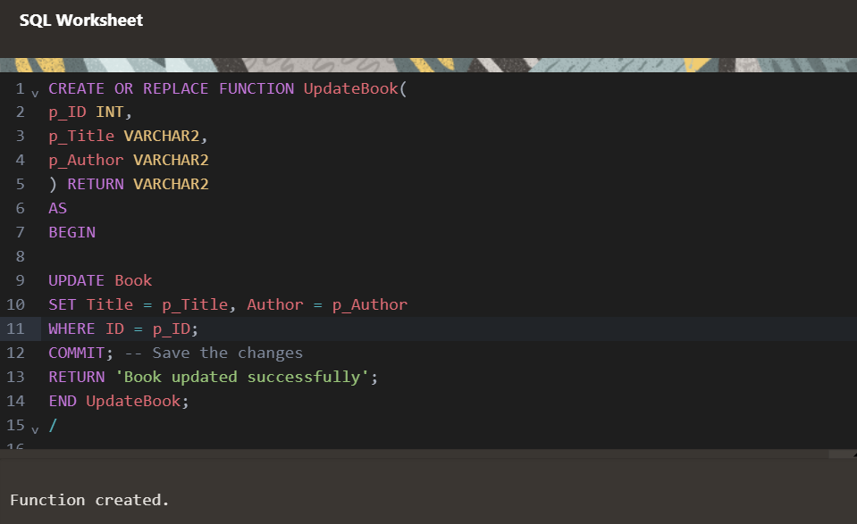

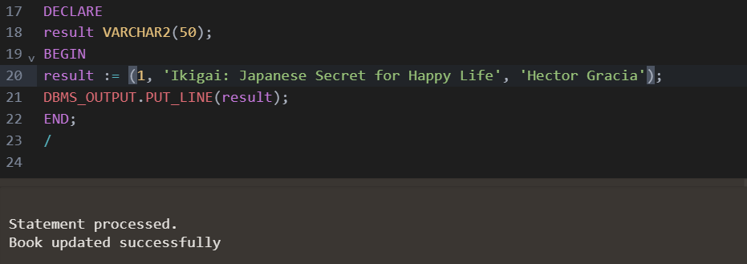

1. **Create a function to display the details of Book table:**

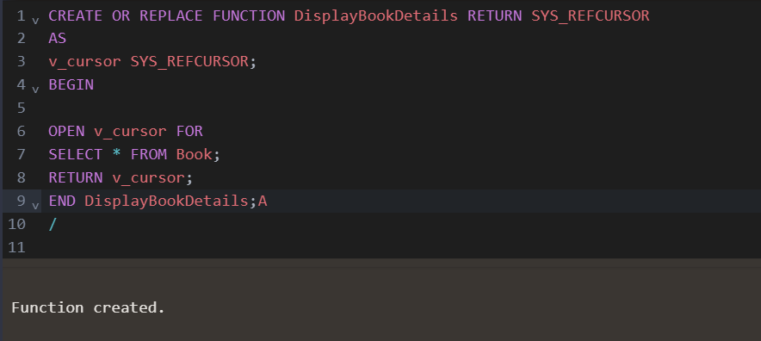

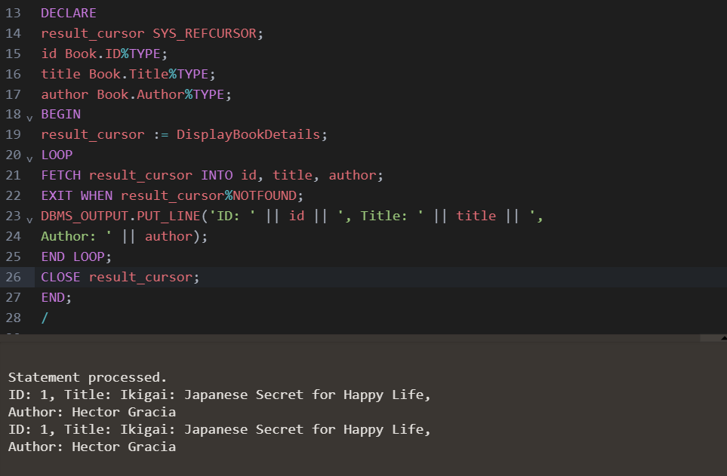

1. **Write a function to calculate the total marks of all students in Subj1 and Subj2. Student1 table contains regn_no, sub1, sub2.**

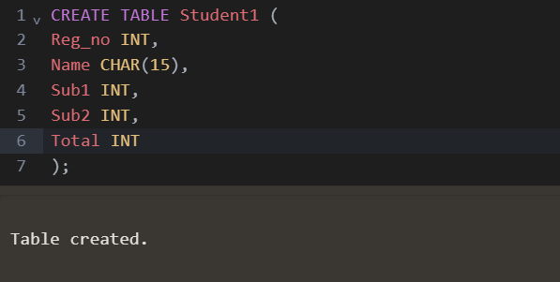

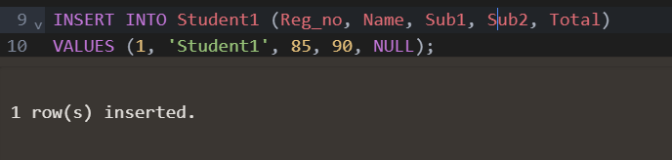

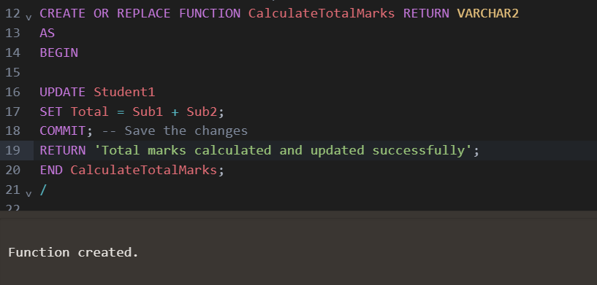

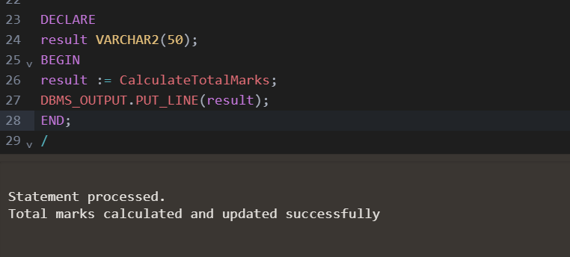

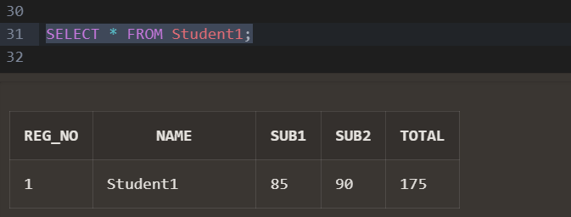

**Conclusion:** Hence by completing this experiment I came to know about implementing Pl/SQL procedures and functions.